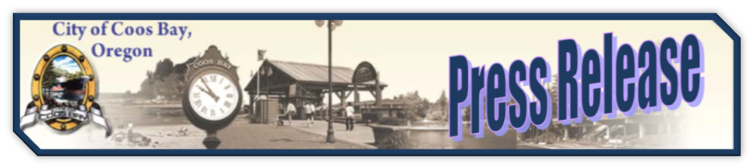

Coos Bay City Hall
500 Central Avenue
Coos Bay, OR 97420
www.coosbay.org

Police Department
(541) 269-8911

Fire Department
(541) 269-1191

Library
(541) 269-1101

Public Works & Development Department
(541) 269-8918

Economic Development
(541) 269-8924

Finance Department
(541) 269-8915

City Manager’s Office
(541) 269-8912
January 10, 2013

REVISED

Temporary Road Closure

Starting January 15, 2013, blade patching and pothole patching will be performed on the following streets:

- The 100 block of South Wasson. “No Parking after 5:00 PM” on Monday, and the street will be shut down Tuesday morning to perform the work. The Street will reopened once work is completed on Tuesday.

- SW Boulevard between Idaho and Montana Avenue will undergo patch repair. You can expect delays while traveling SW Boulevard on January 15, 2013 due to road maintenance work. Traffic flagging will be provided by City maintenance crews. The Public Works and Development Department appreciates your cooperation. Thank you!

If you would like more information about this project, please contact Public Works and Development Department Operations Administrator Randy Dixon at 541-269-1181 ext. 2201 or email at rdixon@coosbay.org

###

