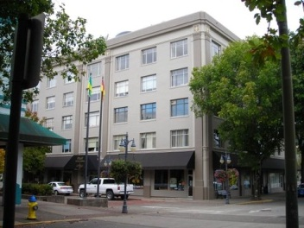 **The Hall Building**

320 Central Avenue, Suite 210

This commercial space is a prime office location, including kitchen/break room with private restroom and private office This commercial space would be great for any professional office or retail space and has tons of parking.

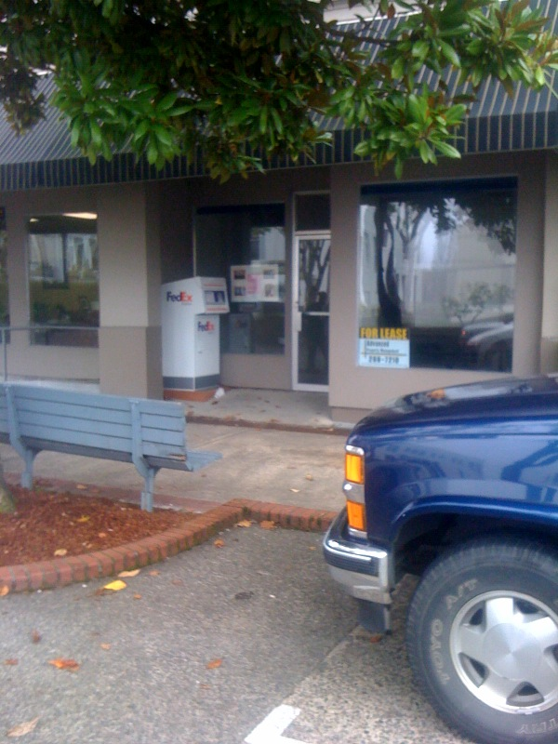

Contact: Advanced Property Management

541-269-7210

Lease $795 / month

Includes water/sewer/garbage

Sq ft 1,000 sf