**Historic Building Preservation Information**

**Oregon State Historic Preservation office (SHPO)** [www.oregonheritage.org](http://www.oregonheritage.org)

Oregon Parks and Recreation Dept: Heritage Programs: State Historic Preservation

Tax Incentives Susan Haylock

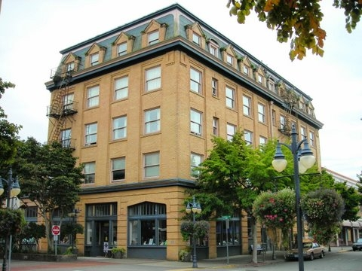[Susan.Haylock@state.or.us](mailto:Susan.Haylock@state.or.us)

503-986-0672

Special Assessment Program

State historic Preservation Office

725 Summer Street NE, Suite C

Salem OR 97301

Grant Program Joy Sears, Restoration Specialist

[Joy.Sears@state.or.us](mailto:Joy.Sears@state.or.us)

503-986-0688

**National Register of Historic Places**

[www.nationalregisterofhistoricplaces.com](http://www.nationalregisterofhistoricplaces.com)

Robert Meinen

503-378-5019

State historic Preservation Office

1115 Commercial Street NE

Salem OR 97310-1001

**Historic Preservation League of Oregon**

The Historic Preservation League of Oregon

24 NW First Avenue Suite 274

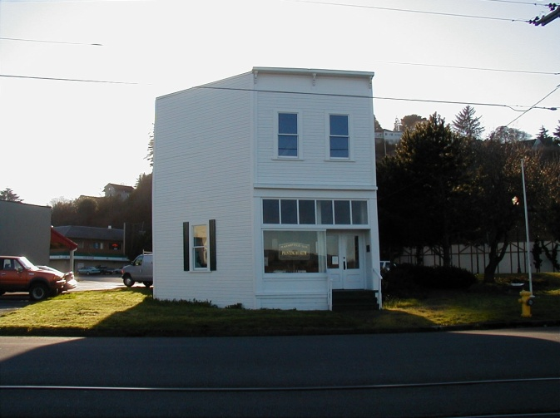 Portland OR 97209

Peggy Moretti, Executive Direction

[PeggyM@HistoricPreservationLeague.org](mailto:PeggyM@HistoricPreservationLeague.org)

503-243-1923

Grants: Apply through SHPO, 50/50 match, $5,000 to $20,000 range

Provide assistance and resource information

Provide workshops on restoration

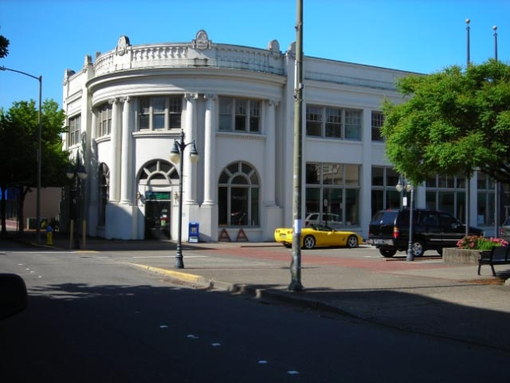

**National Parks Service**

Historic Preservation Grants and Save

America’s Treasures Grant Program

Tax Incentives

Weatherization / Energy Efficiency Programs

[www.nps.gov/history](http://www.nps.gov/history)

**Other Grant Foundations**

**The Kinsman Foundation**

3727 SE Spaulding Avenue

Milwaukee OR 97267-3938

503-654-1668

[grants@kinsmanfoundation.org](mailto:grants@kinsmanfoundation.org)

[www.kinsmanfoundation.org](http://www.kinsmanfoundation.org)

**Ford Family Foundation**

1600 NW Stewart Parkway

Roseburg OR 97471-1957

541-957-5574

[www.manta.com](http://www.manta.com)

**The Collins Foundation**

1618 SW First Avenue Suite 505

Portland OR 97201

503-227-7171

[www.collinsfoundation.org](http://www.collinsfoundation.org)

**Oregon Cultural Trust**

775 Summer Street NE Suite 200

Salem OR 97301

503-986-0088

[www.culturaltrust.org/programs/grant_opportunities](http://www.culturaltrust.org/programs/grant_opportunities)

**City Staff**

City Planning & Zoning

* Laura Barron, Planning Administrator 541-269-8918 [lbarron@coosbay.org](mailto:lbarron@coosbay.org)
* Debbie Erler, Planner I 541-269-8918 [derler@coosbay.org](mailto:derler@coosbay.org)

City Façade Improvement Grant Program

* Joyce Jansen, Economic Revitalization

Administrator 541-269-8924 [jjansen@coosbay.org](mailto:jjansen@coosbay.org)

**Coos Bay Sites Listed on the National Register of Historic Places**

**September 2010**

Year

Property Address Added

American Building aka Coke Building 150 Central Avenue 1991

Carnegie Library 515 Market Avenue 1986

Chandler Hotel 150 South 2nd Street 1984

Coos Bay Nat’l Bank Building aka Bugge Bldg 201 Central Avenue 1989

Egyptian Theatre 229 South Broadway 2010

Elks Temple aka BPOE Lodge 1160 195 South 2nd Street 1983

Koski Building 241 North Broadway 1994

Marshfield City Hall aka Coos Bay City Hall 375 Central Avenue 1997

Marshfield Hotel aka Tioga 275 North Broadway 1983

Marshfield Sun Building 1049 North Front Street 1973

Myrtle Arms Apartment Building 613 Central Avenue 1985

Nasburg-Lockhart Home 687 North 3rd Street 1985

Nerdrum-Conrad House 979 South 5th Street 2004

Nerdrum-Hjalte House 955 South 5th Street 1993

Olsson, Capt. Bror W. Home 631 South 10th Street 1986

Seelig-Byer House 1920 North 14th Street 1994

The Hub Building 125 Central Avenue 1992

Tribal Hall of the Confederated Tribes 338 Wallace Avenue 1989

Tower House, Major Morton 486 Schetter Street 1985

Tower-Flanagan Home 479 Newmark Avenue 1984

**Statewide Inventory of Historic Sites and Buildings**

**Oregon State Historic Preservation Office 1976**

Joseph W. Bennett Home 202 Alder Avenue

Boy Scout Cabin 850 West Park Roadway

Carnegie Library 515 Market Avenue

Cape Arago Company Sawmill 200 Ross

Powers-Conrad home 480 Hall Street

Egyptian Theatre 229 South Broadway

Empire City Fort Newmark and Empire Blvd

Empire Pioneer Cemetery

Flanagan House 474 Park Avenue

Horsfall House 1007 South 2nd Street

Jeff Luse Home 487 North 4th Street

Koski Building 241 North Broadway

Myren-Hillstrom Home 353 South 5th Street

Newburg-Lockhart Home 687 North 3rd Street

Nerdrum House (Adel sperger Powers House) 955 South 5th Street

Ben Ostlind home 415 South 6th Street

Rudnas Home 232 Park Avenue

Sengstacken Home 682 North 3rd Street

Major Morton Tower Home 486 Schetter Avenue

Tower-Flanagan Home 476 Newmark Avenue

Williams Home 936 Central Avenue

\\citymansrvr\home\jjansen\my documents\downtown development\business retention-recruitment\historic building incentives-grants information.docx