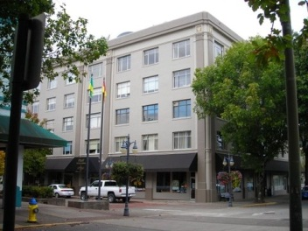**The Hall Building**

320 Central Avenue, Suite 210

This commercial space is a prime office location, including kitchen/break room with private restroom and private office. Located in the downtown business district, the space would work well for a professional office or retail. On-street parking is available for customers and public parking lots are close by.

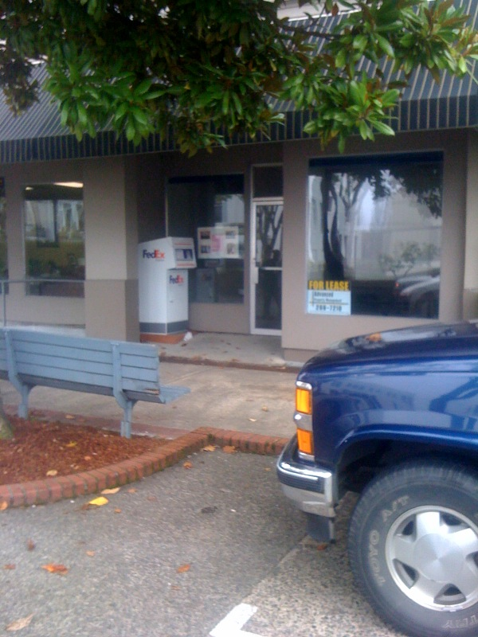

Contact Advanced Property Management

541-269-7210

Lease $795 / month

Includes water/sewer/garbage

Sq ft 1,000 sf