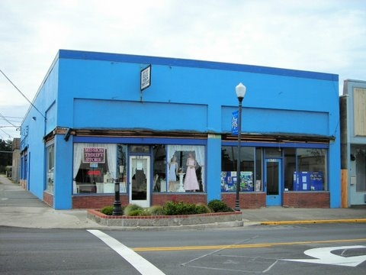
Star of Hope
657 Newmark Avenue
January 2010

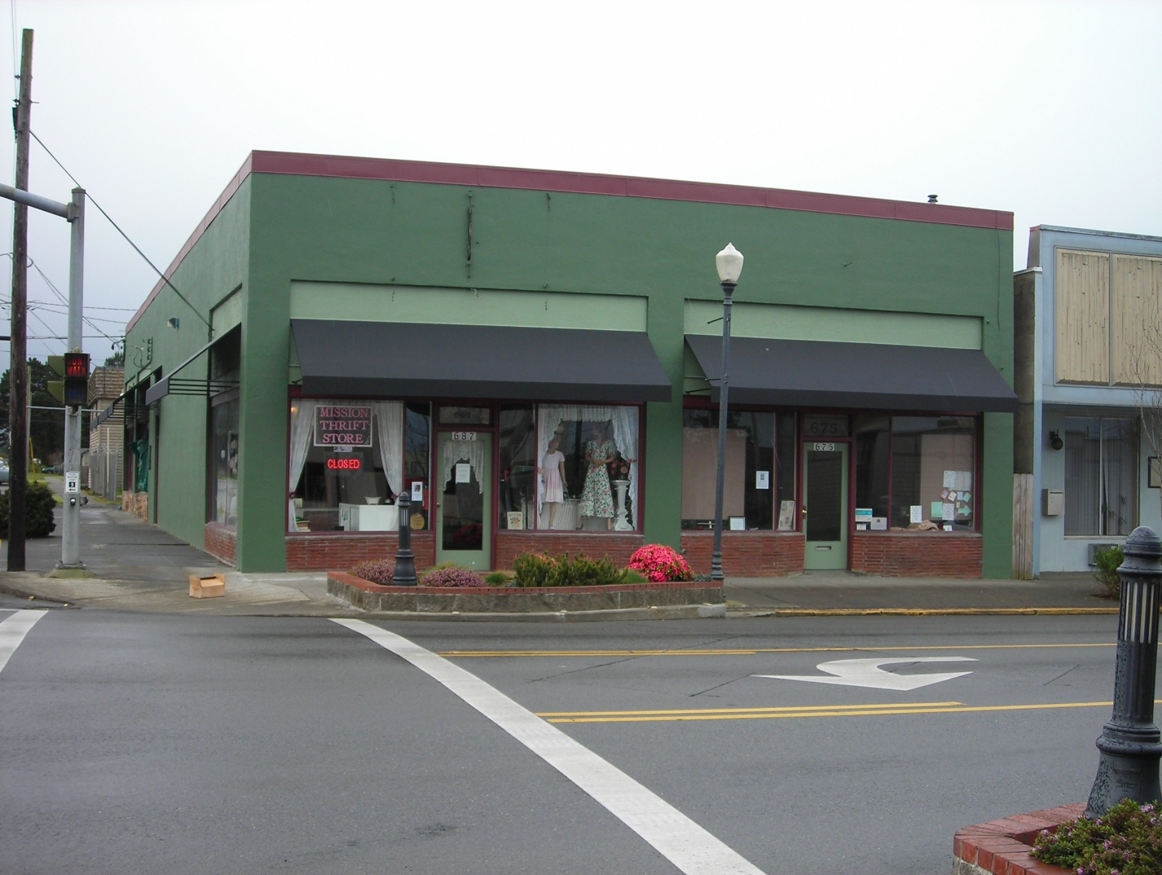
Before

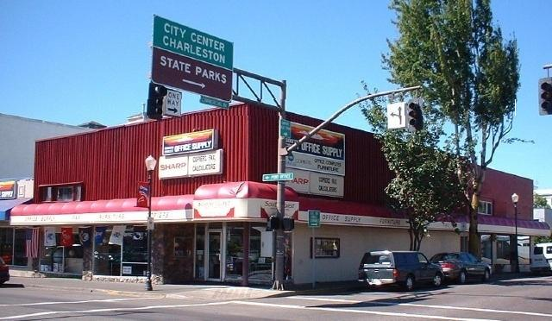
After
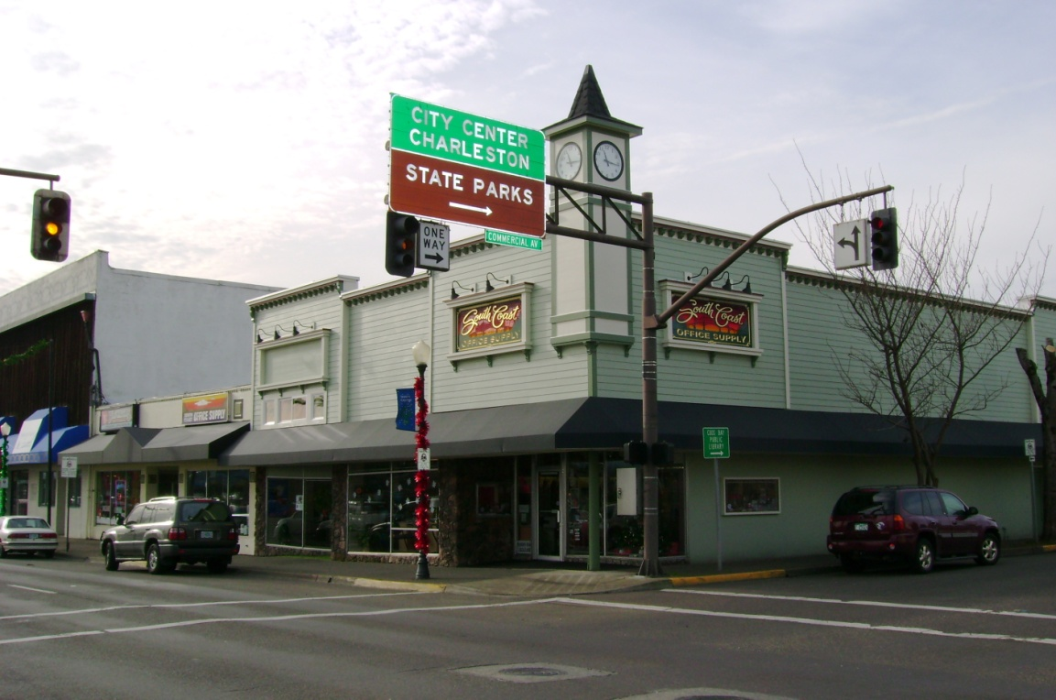
Before

South Coast Office Supply
199 North Broadway
April 2007 After
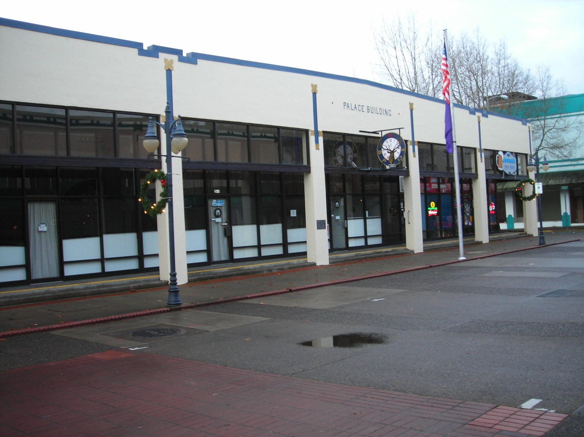
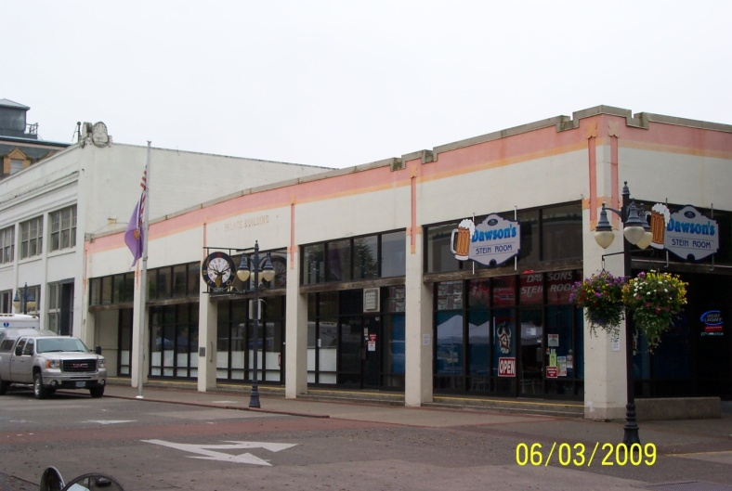

Before

Coos Bay Elks Club After
265 Central Avenue
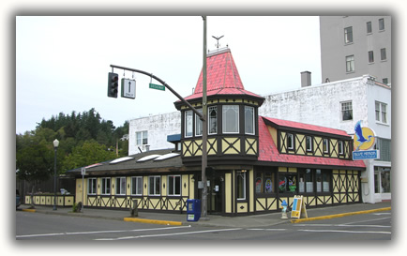
August 2009

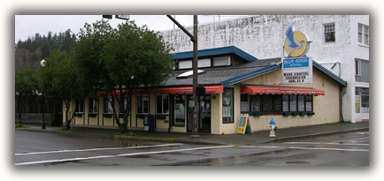

Before After
Blue Heron Bistro
100 Commercial Avenue
April 2007

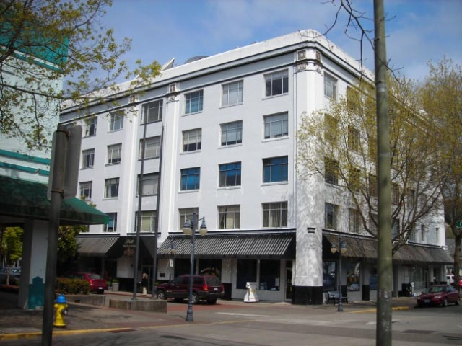

The Hall Building

320 Central Avenue
May 2008

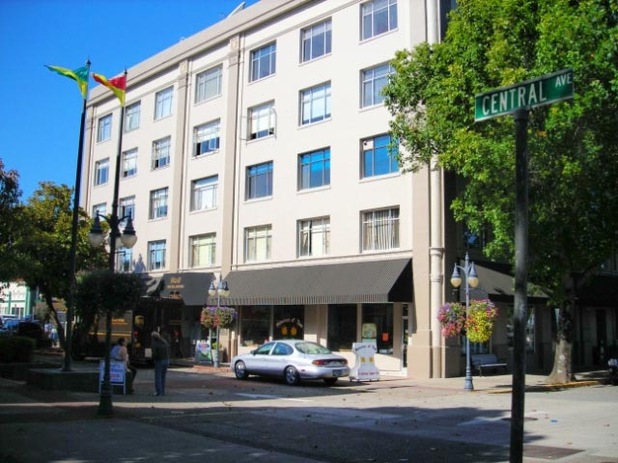
Before

After

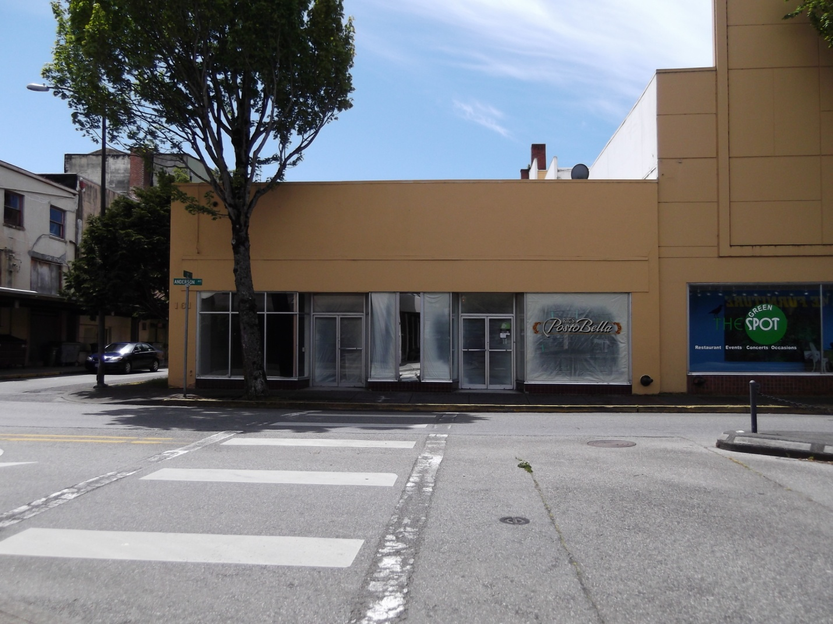

First Call Resolution
161 Anderson Avenue

June 2011

Before

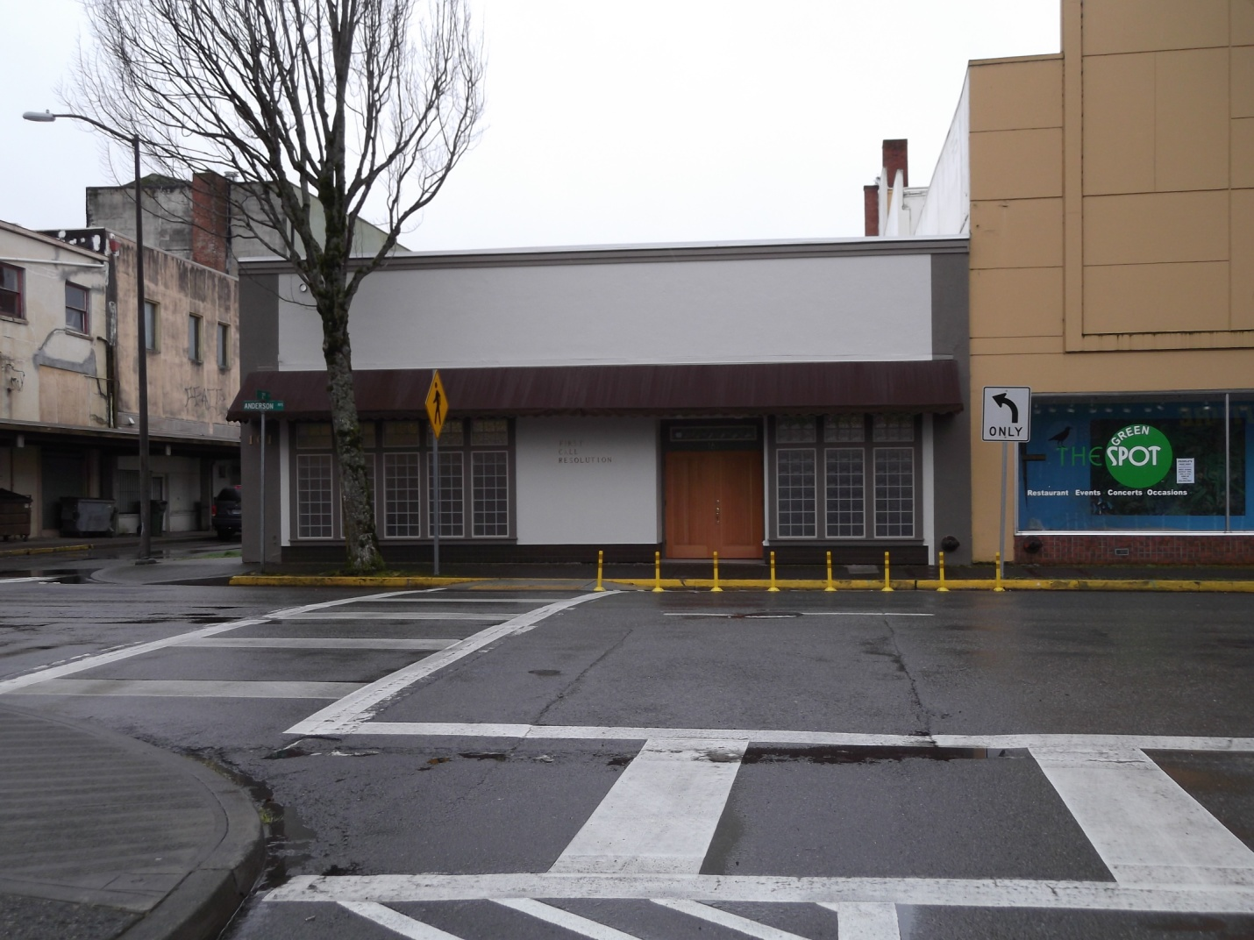

After

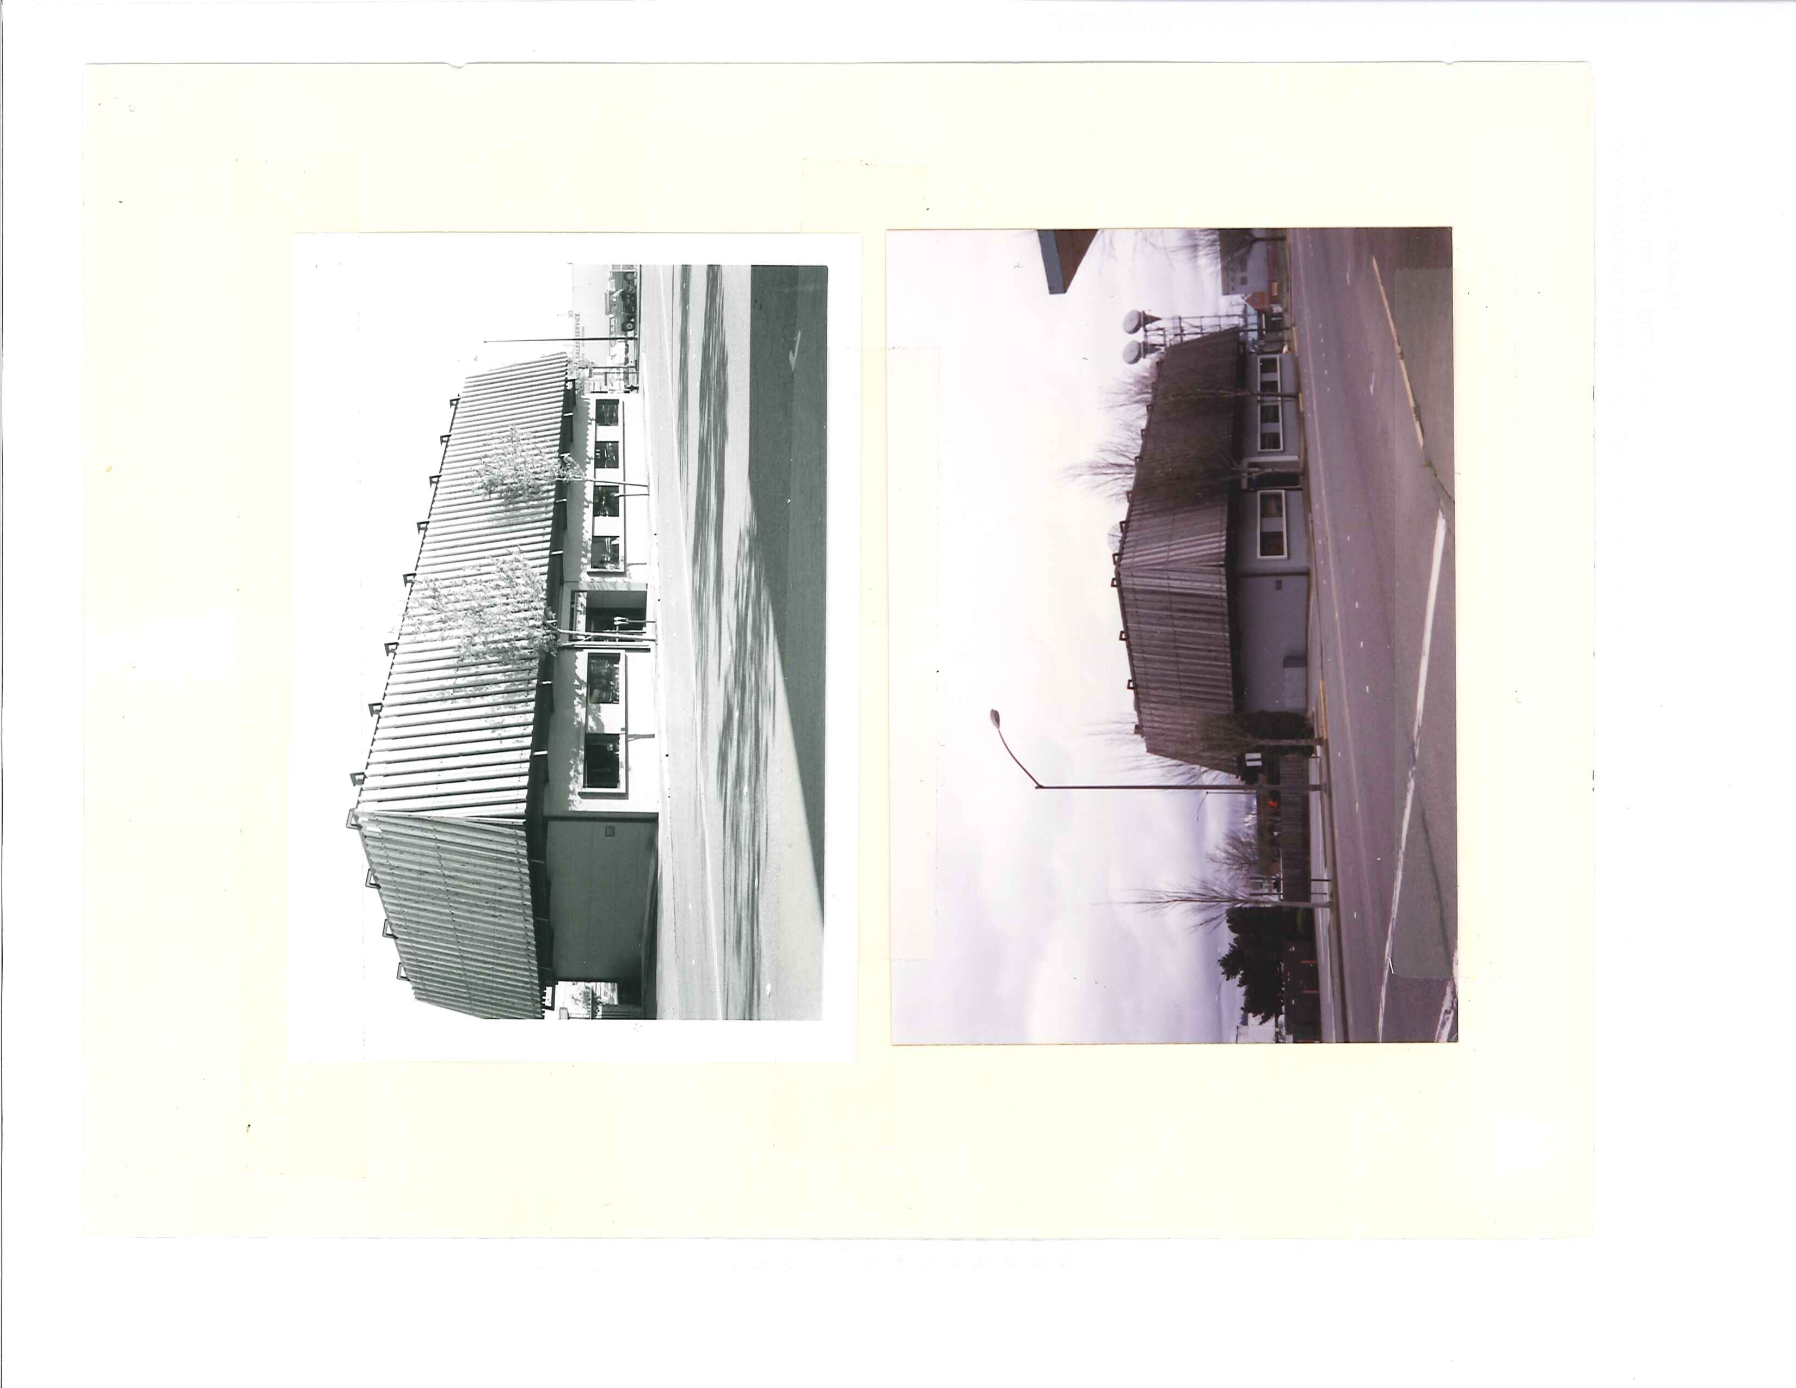
Michael Gordon, CPA
290 South 4th Street

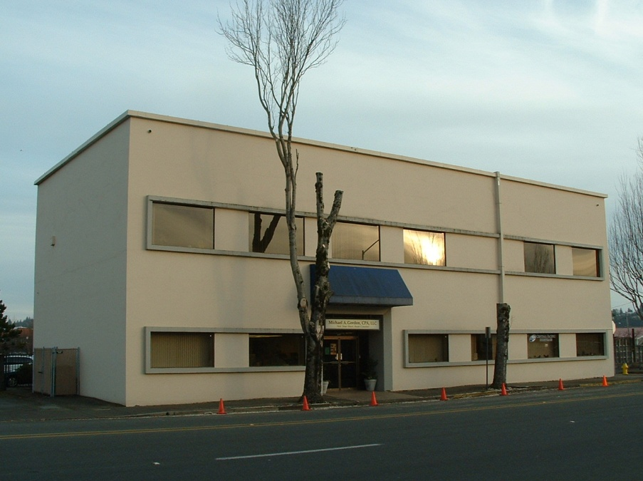

Early 1980s

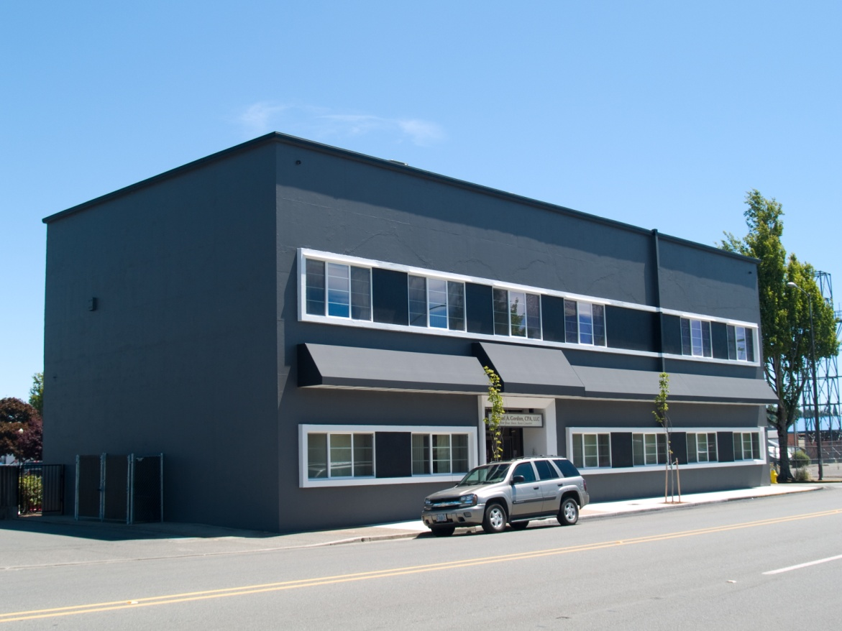
January 2007

June 2007

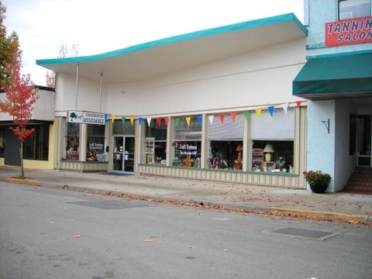
Rifkin Building
175 South 3rd Street

March 2010

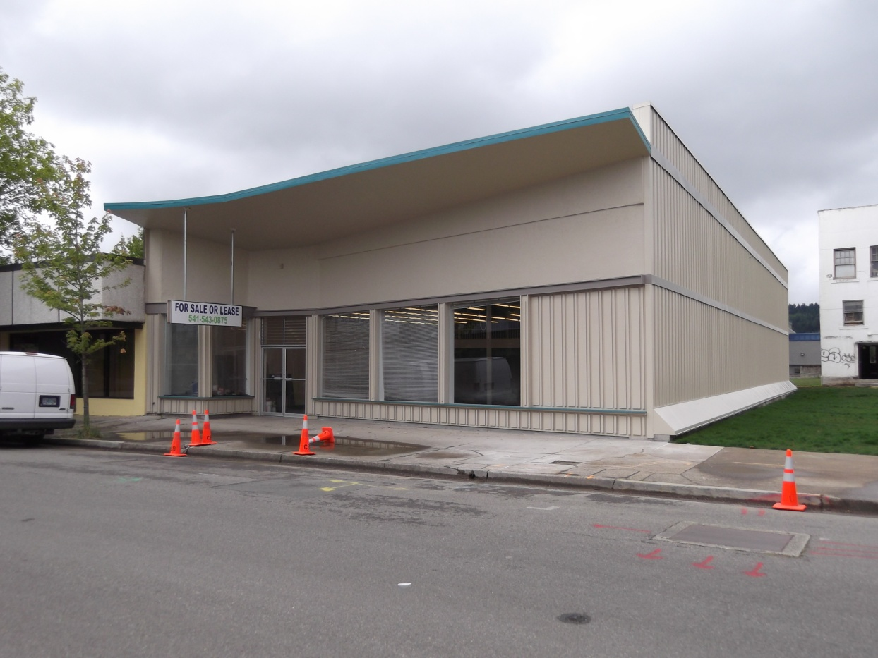

July 2011

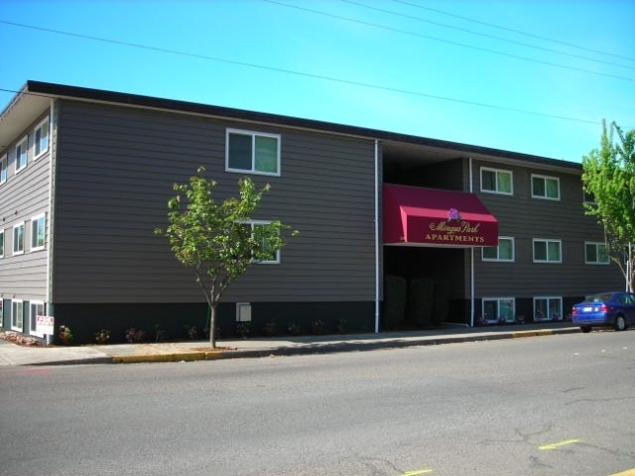

Mingus Apartments
503 Commercial Avenue
August 2007

After

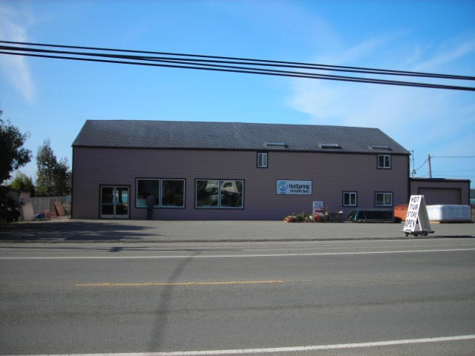

Bay Area Hotsprings

526 South
Empire Blvd

December
2007

After

IN PROGRESS PROJECTS

Beijing Restaurant
1090 Newmark Avenue

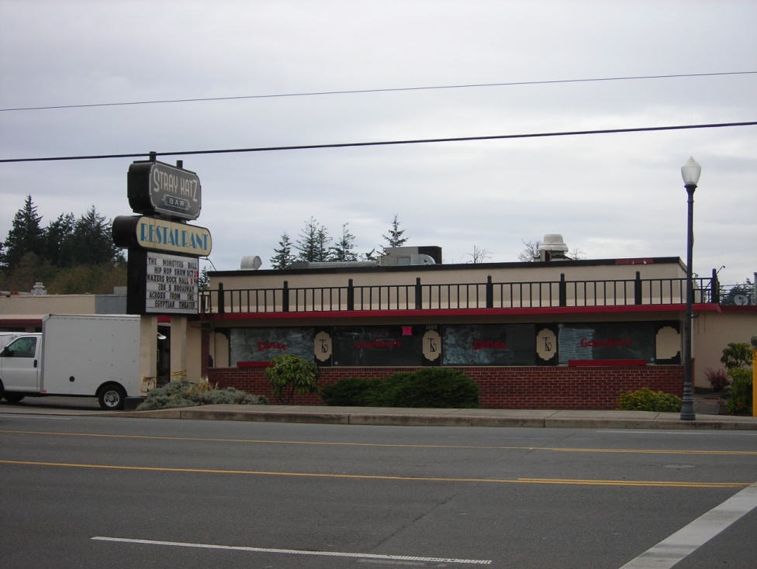

October 2010

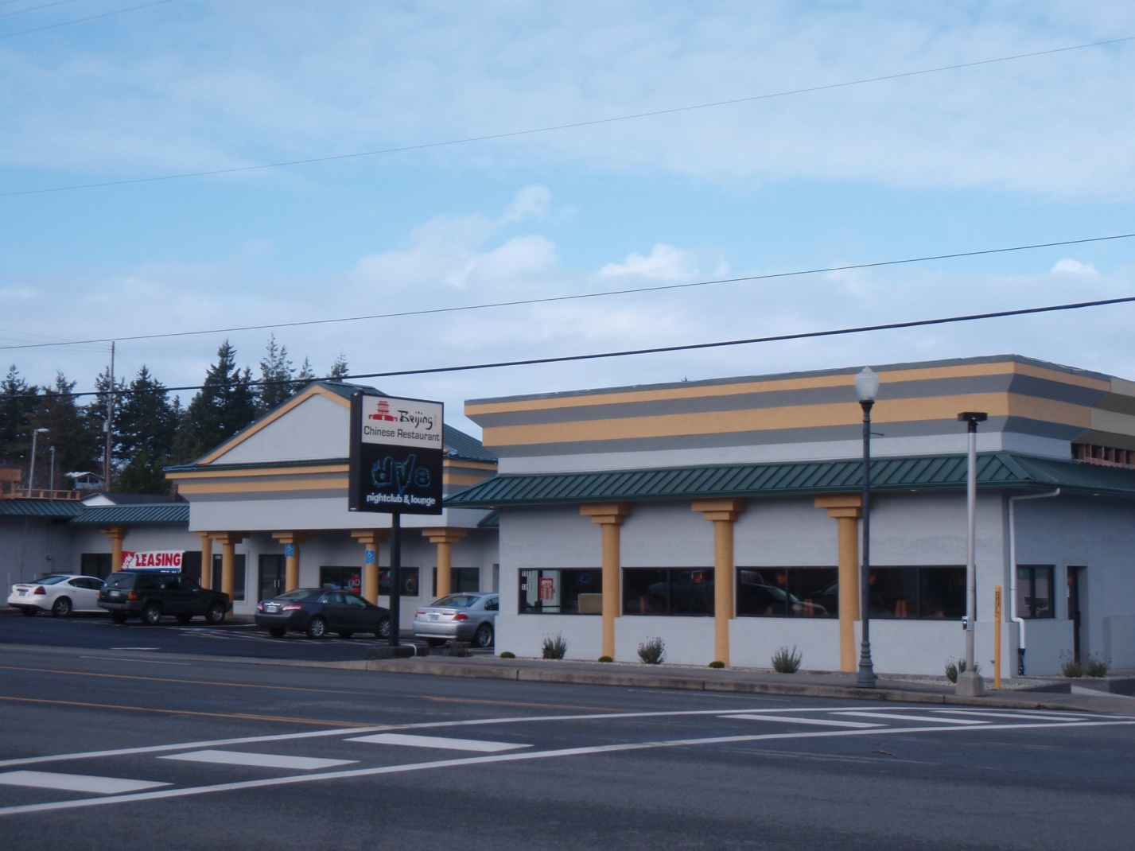

January 5, 2012

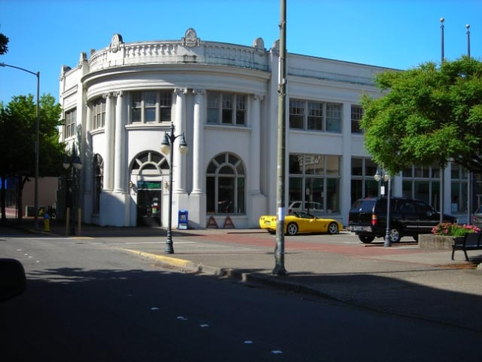
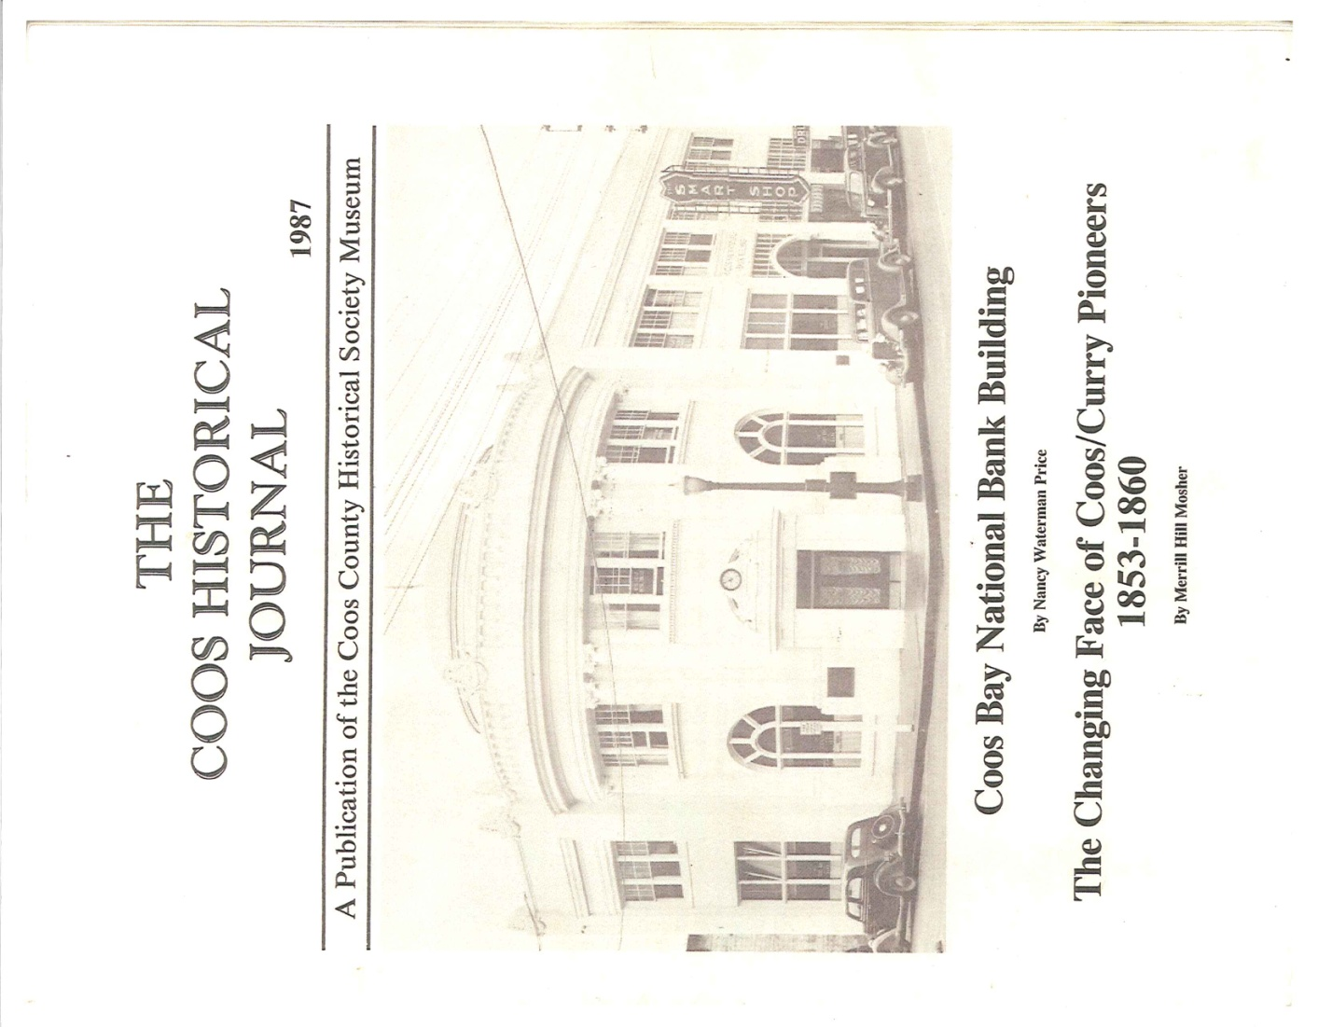
US Bank / Bank Brewery
201 Central Avenue

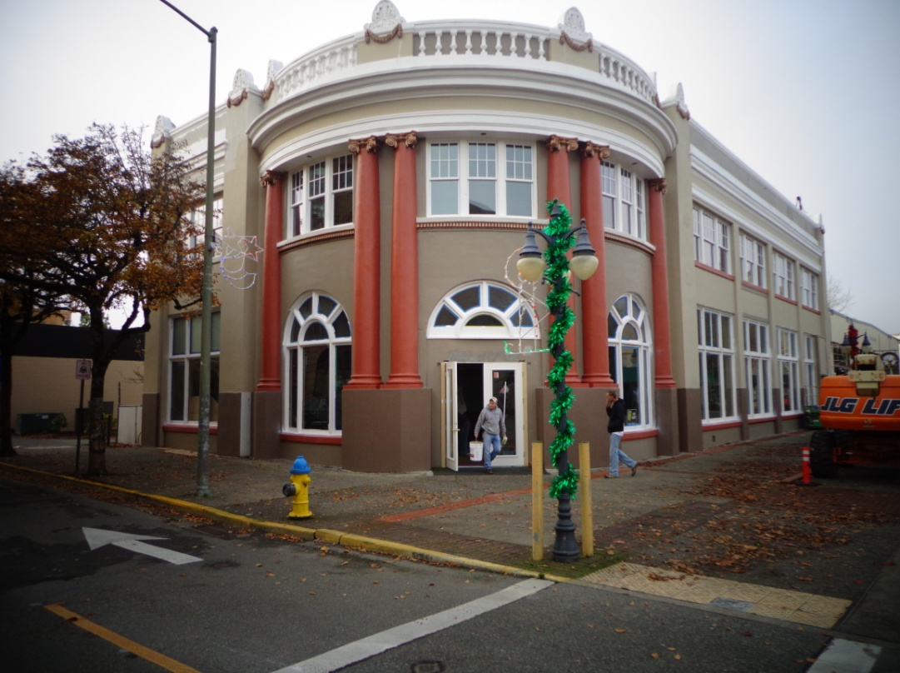

1920s

Current
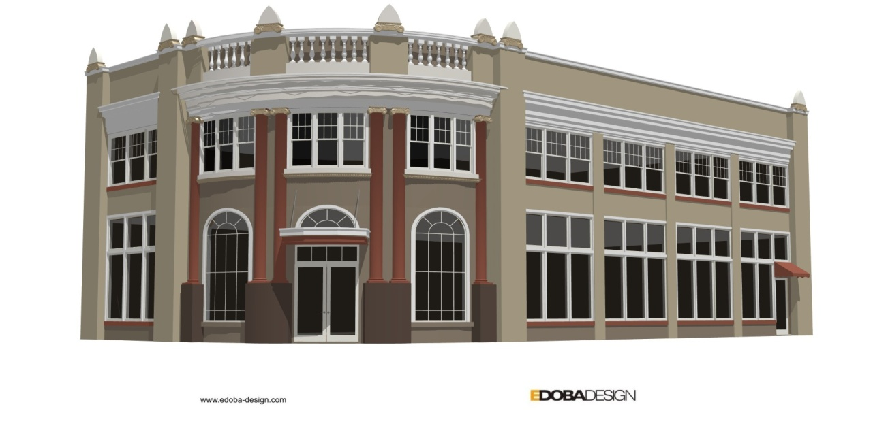

Approved project

Dec 2012
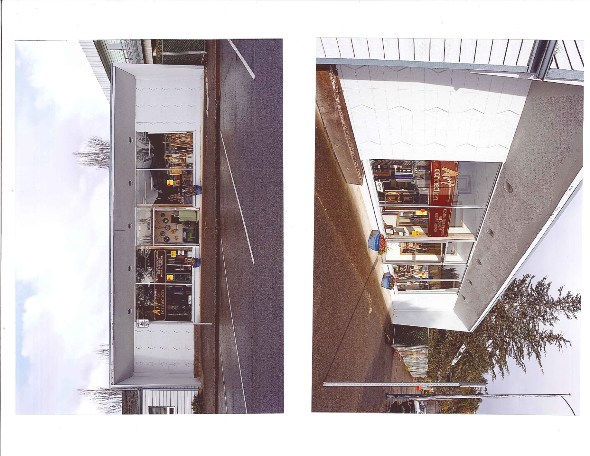

Webster Building / Art Connection
165 South 5th Street

March 2012

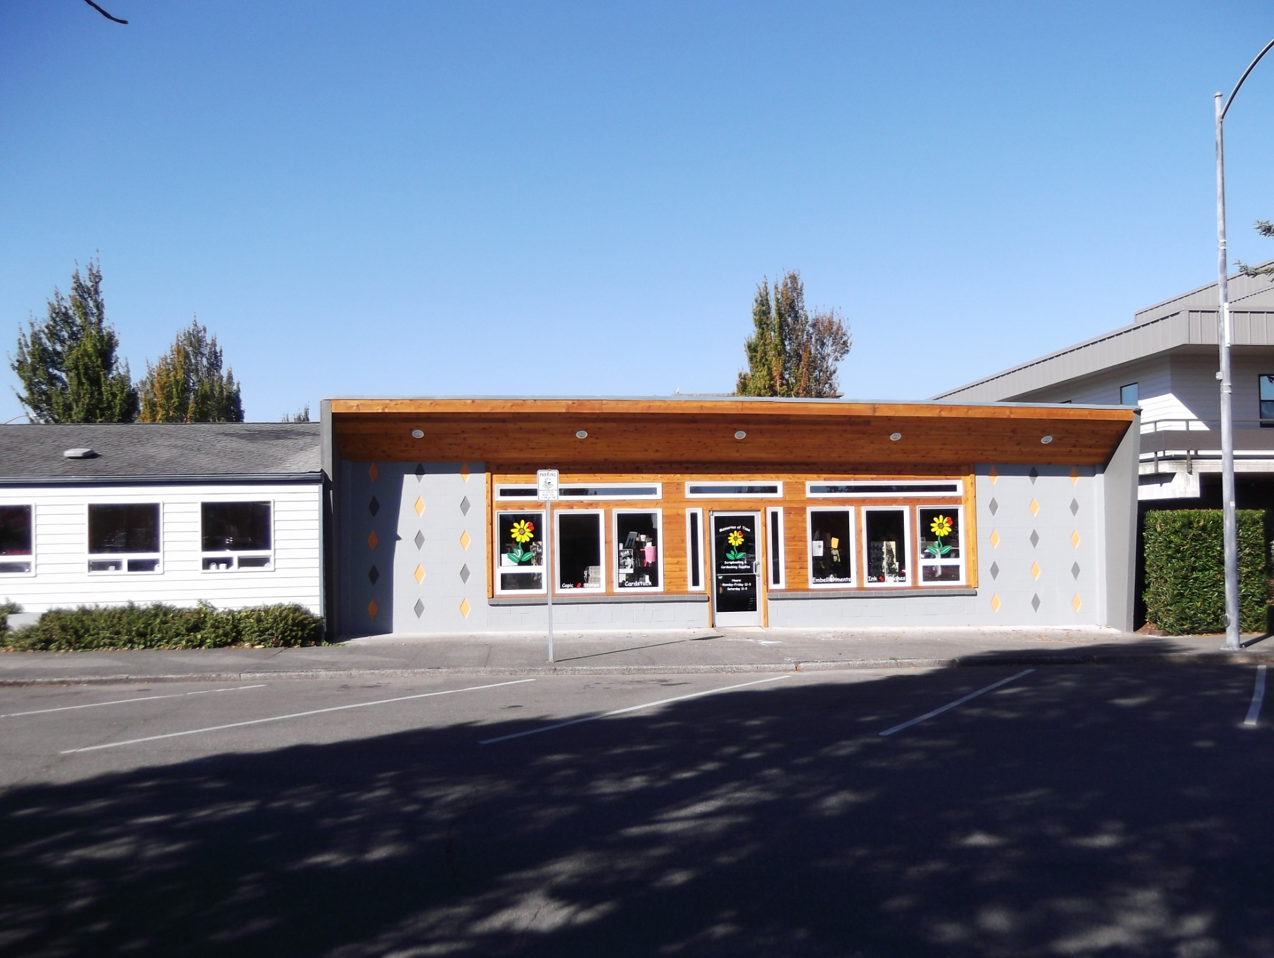

May 2012

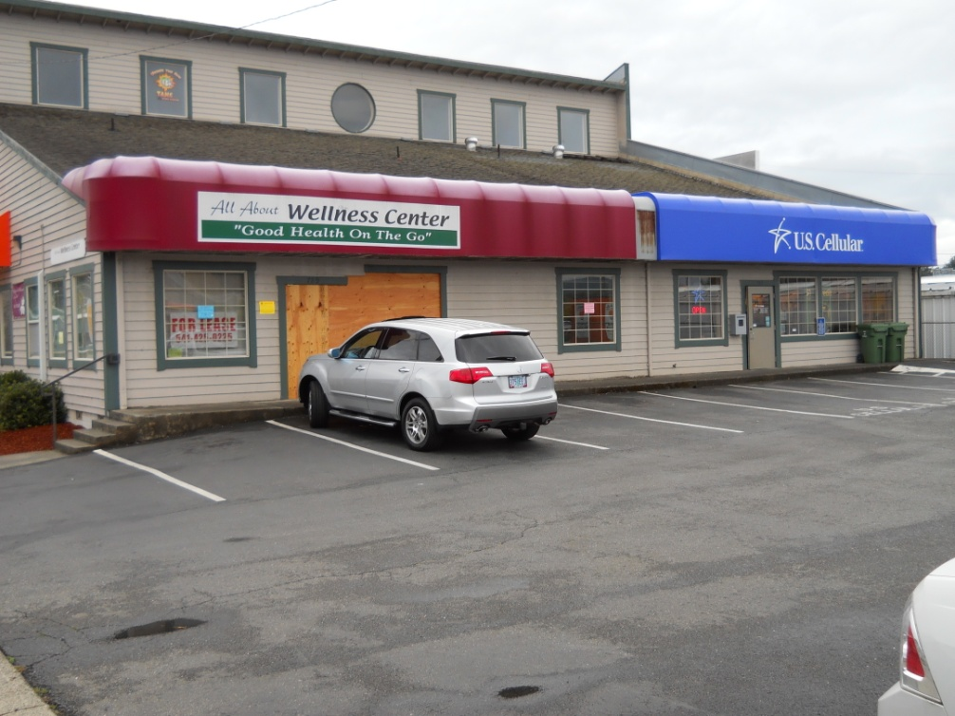
Little Caesars
789 South Broadway

February 2012

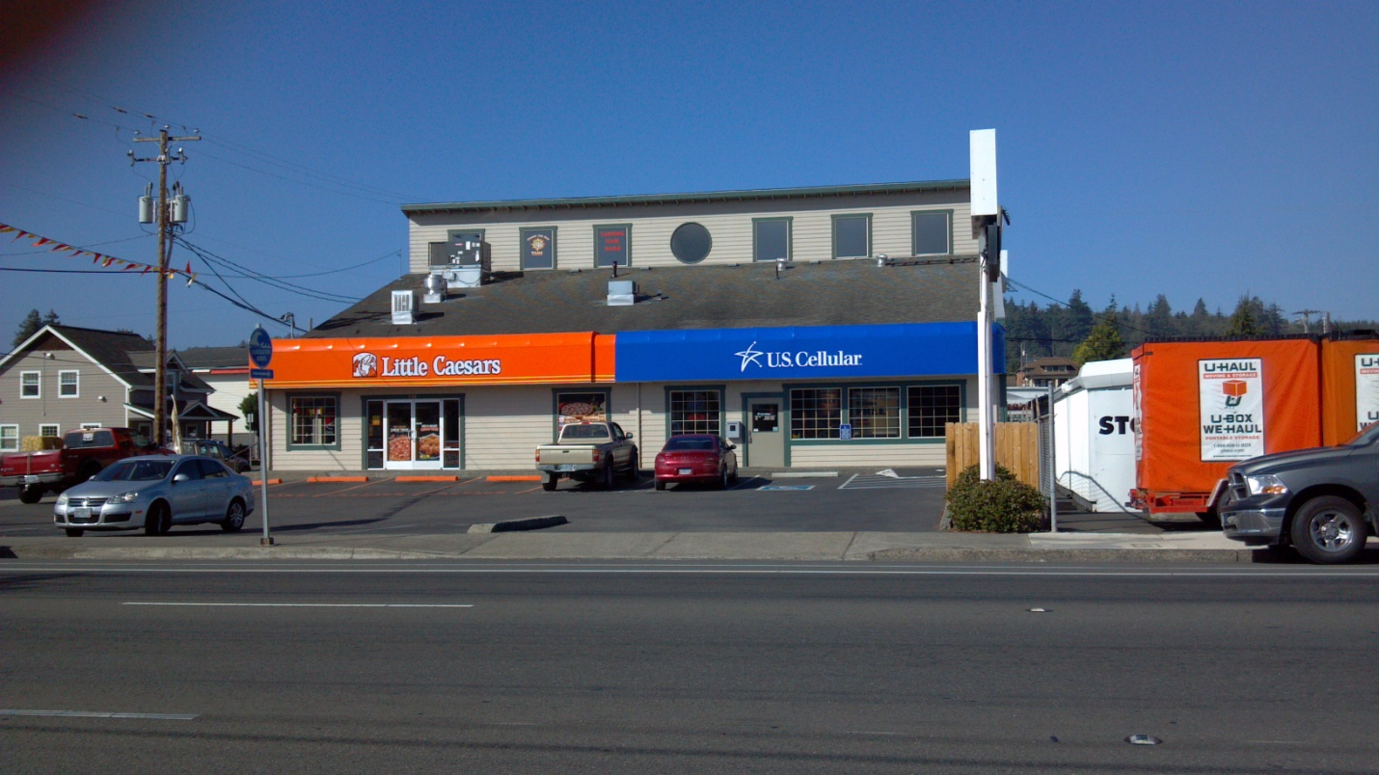

March 2012

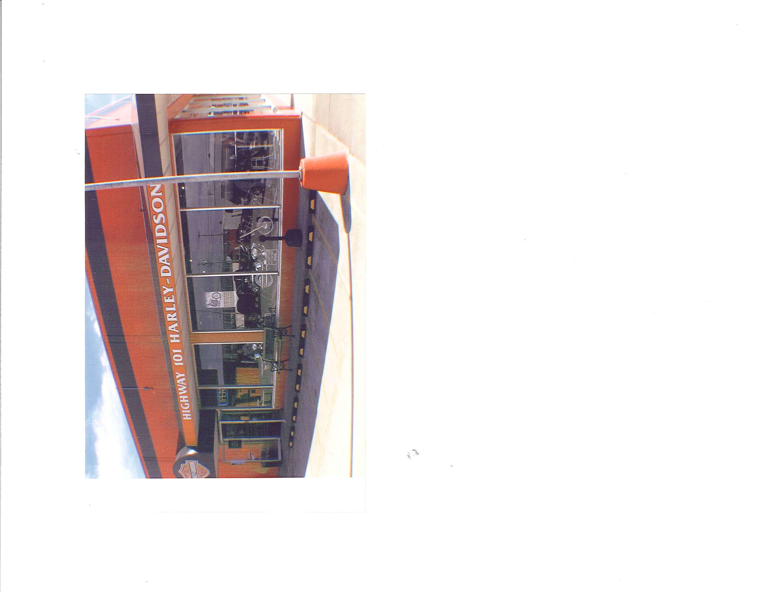
Hwy 101 Harley Davidson
536 South 2nd Street

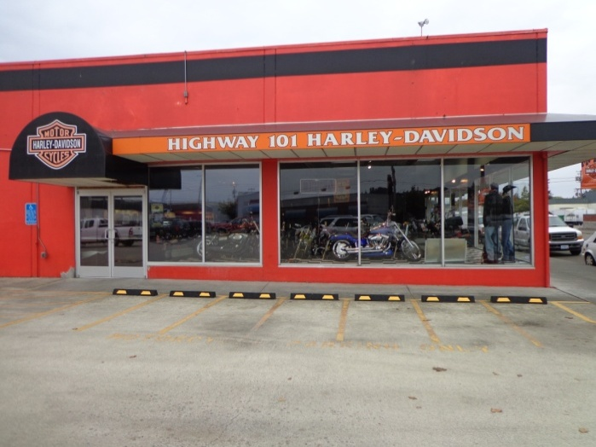
January 2012

October 2012

