**Anderson & 4th Street**

200 South 4th Street

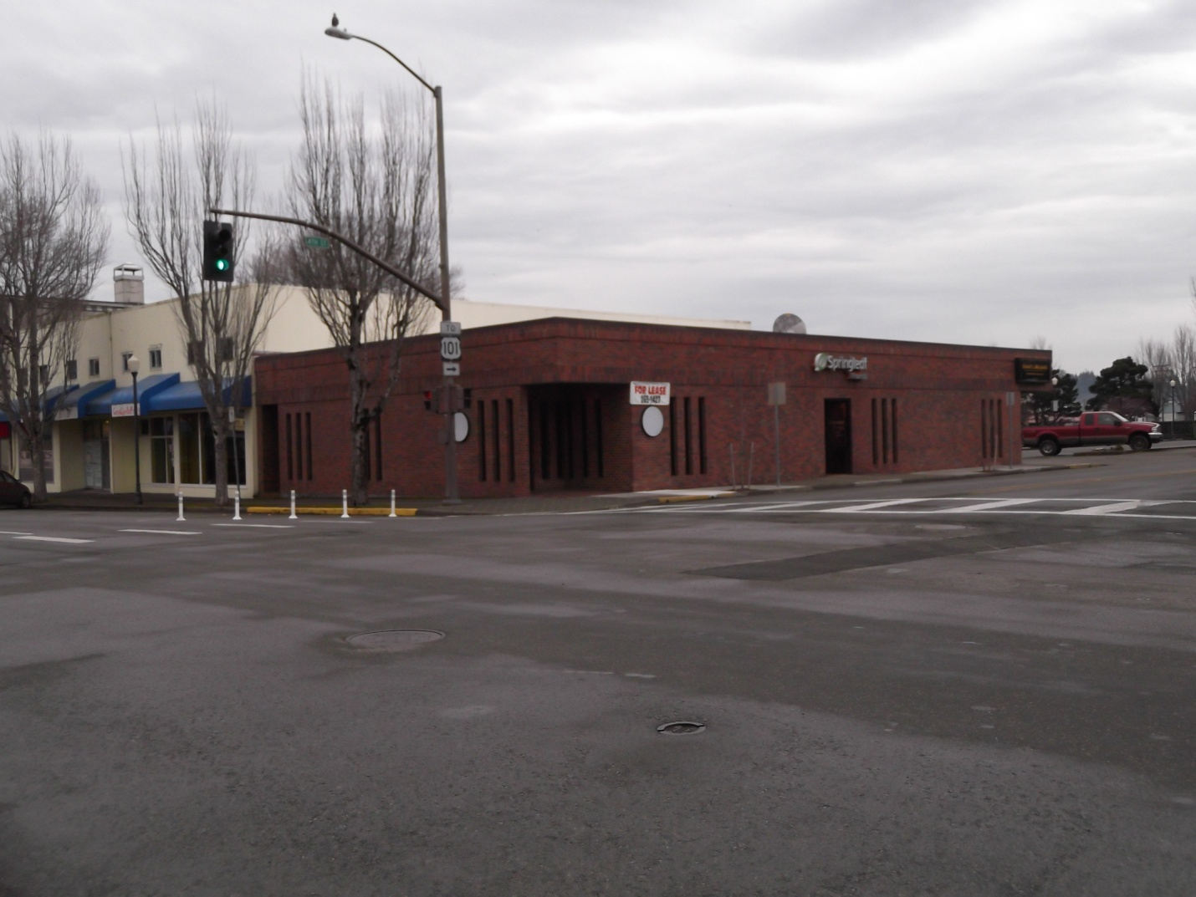Professional office space located at 4th and Anderson in downtown Coos Bay business district with on-street parking on Anderson and adjacent to public parking lots. New carpet, good lighting. For office use only.

Contact: Grant Walding

541-269-1427

Lease $1,150 / month

Includes water

Sq ft 1,000 sf

\\citymansrvr\home\jjansen\my documents\downtown development\downtown property\property info\anderson and 4th brick building apr 2012.docx