**Anderson Avenue Property**

367 & 383 Anderson

Prior locations for Curves and Coos Cardio party

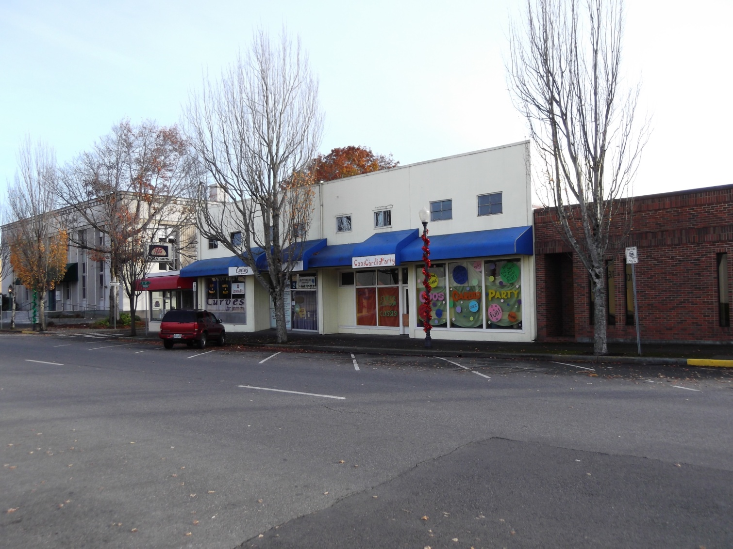

For Sale $135,000

Sq ft Two levels, total of 13,000 sq ft

* Two commercial spaces on street level with front and rear access
* 2nd floor office spaces, need remodeling
* Located in the heart of downtown Coos Bay next door to the Coos Art Museum and across the street from Ticor Title.
* Busy street great for business.
* On-street parking as well as close public parking lots.

Contact Information – Pollman Reinhard – 1845 HWY 126, Florence, Oregon 97439; 541-404-6701